Information Architecture of Ubuntu.com

## Information Architecture Topology

Ubuntu.com is a very large site with an extreme amount of content to deliver. In order to do to effectively, the site utilizes a hierarchical typology that employs a top level navigation bar which provides links to its 17 subdomains. Within each subdomain, a second level navigation bar provides a further hierarchical typology of nested links for each section, as well as a full mesh typology of links that can be found in the footer section. This provides easy navigation from any page as well as separates the content effectively based on related pages.

The main section at [www.ubuntu.com](http://www.ubuntu.com) contains 8 main navigation links, which offers a reasonable amount of breadth at this level. These main navigation links contain between 2 and 8 sub-links respectively which provides a reasonable amount of depth for each, without allowing the user to get lost. There are an additional 4-6 links within these sub-pages, offering a reasonable amount of breadth at this level as well.



## Information Architecture Process

Ubunto.com caters to a wide variety of users from well-educated and informed techies looking for technical content, to casual users who are looking for general information, as well as offering ecommerce, multimedia content and branding information. Each section is distinct and is labelled appropriately through the link sections as well as through effective and descriptive headlines. The pages are not overloaded with information and provide a logical flow of information through the pages to provide a comprehensive picture of the content being delivered.

Through semantic organization, Ubuntu.com effectively organizes its over 4000 pages of content into logical subsections. Navigation is both task-based and user-based, based on the content being delivered. For example, the flow of a user looking for information about what Ubuntu is, is quite simple and straightforward compared to a user who is looking to download a specific piece of software for a specific device out of the many hundreds of options available. As well, with the different divisions of the company, certain sections have been determined by the organizational structure of the company and have been architected into the additional subdomains. The overall breadth of the content being delivered is large and thus makes initial navigation somewhat overwhelming, though Ubuntu.com seems to have implemented a reasonable architecture to compensate for this.

## Information Architecture Sitemap

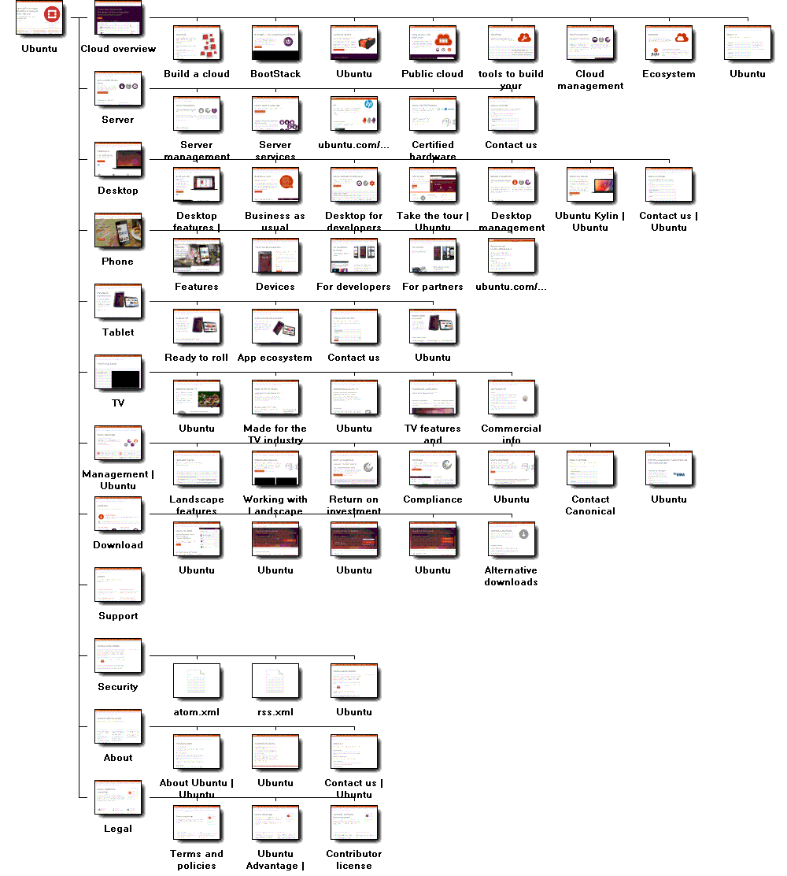[www.ubuntu.com](http://www.ubuntu.com)